M3_Car_Wiper_System

**ABSTRACT**

The Car wiper system is used to clean the car front and back glasses and to keep drysnow, ice, washer fluid of the both glasses. And in this work i am performing the car wiper system in stm32f407vg microcontroller board. And with the help of this we are going to perform turn on the car etc. So lets look into the car wiper and its types.

**OLD CAR WIPER SYSTEM:**

**Layout of a typical link type wiper system .**

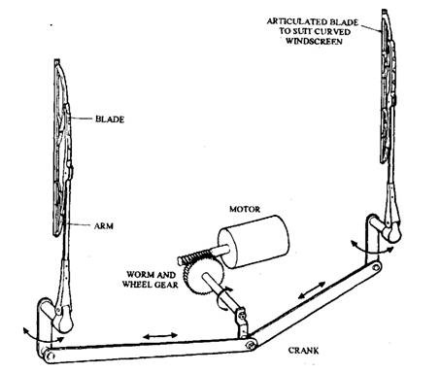

This wiper system can perform the following tasks.  
(a) Efficient removal of dirt, water and snow.  
(b) Operation in the temperature range of 243 K to 353 K.  
(c) The ability to pass the stall and snow load test.

-: A service life of around 1500 000 wipe cycles, (e) Resistance to corrosion from acid, alkalis and ozone. For meeting the above requirements, proper design and manufacturing with good quality components are required for both the wiper and washer systems. The actual method of cleaning the screen by the blades can vary provided that the legally prescribed area of the screen is cleaned. Almost all of the wipers are operated electrically. Also, today it is a common practice to fit two wiper blades for the front windscreen and both blades driven from a single motor. As per the law the wiper on the driver’s side must operate effectively and efficiently. Hatchback cars often use a wiper for the rear window and some expansive cars also install wipers for the headlamps.  
Considerable driving force is required for a rubber wiper blade to move across a glass surface, especially when the blade has to sweep away a large volume of water or snow.

**Wiper Motor Permanent-magnet Type:-**

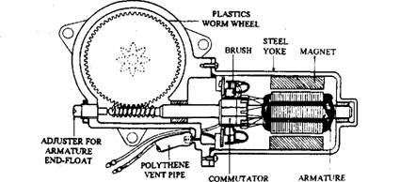

The construction of a single speed motor is The armature with 8-slots is mounted on self lubricating sintered bushes. Two carbon brushes, set 180 degrees apart, rub on an 8 segment commutator generally installed at the driving end. Two strong permanent magnets are bonded to the steel yoke using an adhesive, which is sometimes coated externally with non-ferrous metal to protect it against corrosion. A steel worm, formed on the end of the armature, drives a plastic worm wheel at a speed of about l/10th the speed of the armature. The motor has the output drive through a pinion gears, driven directly by the worm wheel. At the joint faces of the motor, rubber seals are fitted to protect it from moisture. A polythene pipe is used to vent the gases formed by arcing at the brushes.

**Typical wiper motor .**

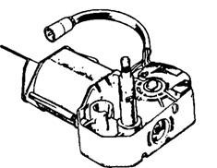

:-The wiper motors now are mostly of permanent magnet three brush types, which are driven through a worm gear to increase torque and reduce speed. The three brushes permit two speed operations. The nor­mal speed is achieved through two brushes placed in the usual position opposite to each other. For a fast speed the third brush is installed closer to the earth brush.  
This design reduces the number of armature windings between them, which reduces resistance and consequently increases current and hence speed. Typical values for wiper motor speed and hence wipe frequency are 45 rpm and 65 rpm at normal and fast speed respectively. The  
motor must overcome the starting friction of each blade at a minimum speed of 5 rpm. The following equation can be used to calculate torque required by the motor.

**Automated Type Wiper Syetem:-**

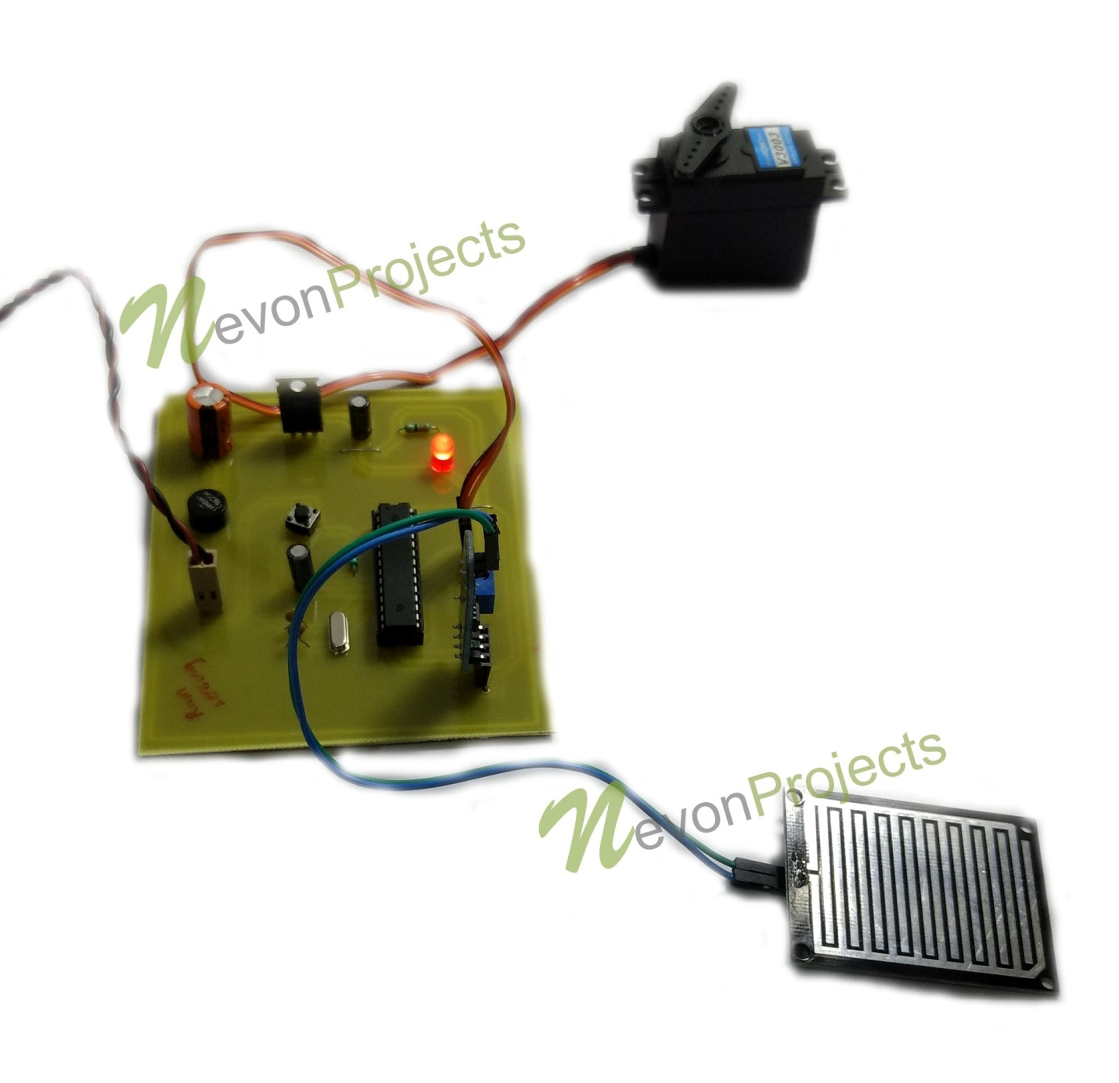

:-The automated rain wiper system is used to detect rainfall and activate automobile rain wiper automatically without driver interaction. The system is developed to mitigate driving distractions and allow drivers to focus on their primary task of driving. The distraction eliminated with the development of this product is the manual adjustment of windshield wipers when driving in precipitation. The few seconds that a driver takes their attention off the road to adjust a knob while driving in poor weather conditions could potentially lead to car accidents.The system uses a combination of impedance and rain sensor to detect rain and its intensity. The system contains a controller that takes in the input signals from the sensors and controls the operation of the windshield wipers based on those input signals The aim of this project is to help reduce accidents that happen as a result of the driver intending to clean the windscreen when rain is falling thereby taking the attention of the driver off the road when he or she is switching on and off the wiper. In rainy days we suffer from the act of sprinkling of water on the front glass of our wheeler. While driving, when drivers cannot see visibly on-road vehicles they try operating the wiper on glass manually, at times switching on and off intermittently and this distraction might cause vehicle accident. If we apply any kind of sensor on glass which senses the act of sprinkling water, by automation, the wiper will be operating automatically. When the water hit the sensor, it will send a signal to the system thus triggering the wiper motor. Once the sensor does not detect any water, the wiper will stop. This will reduce the human interface that has been stated earlier. An addition to this invention is that the wiper automatically push up from the windscreen when the engine is shut off.

## ****Types of Wiper Motors****

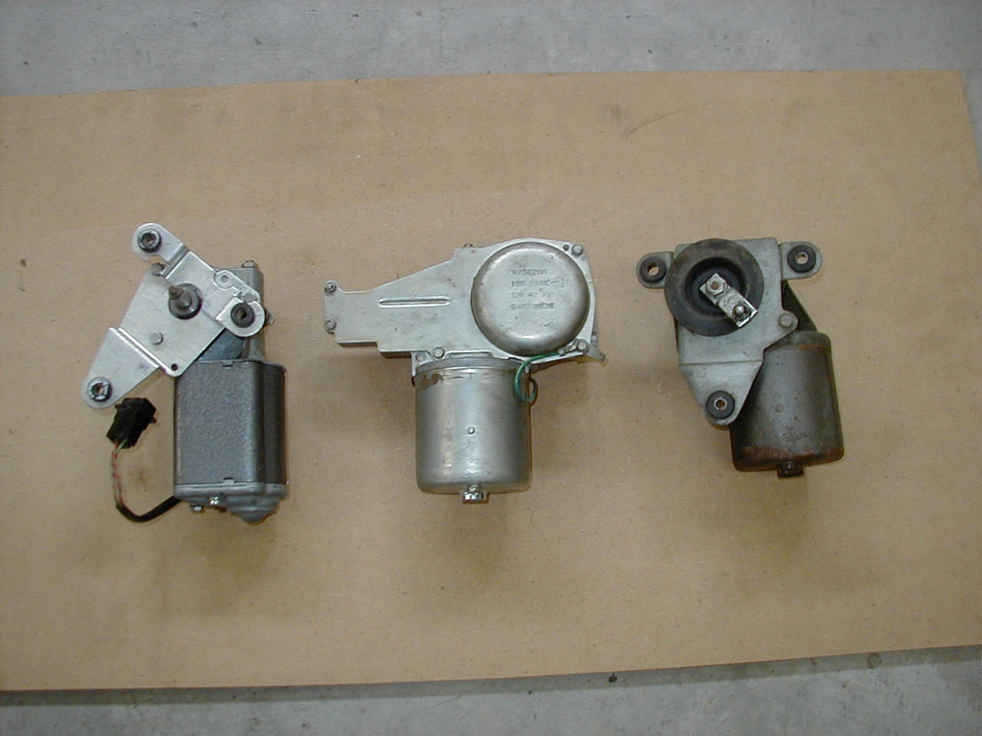

There are various types of the wiper motor. It’s important that you’re aware of them especially when looking to buy a replacement wiper motor for your car. It will help you to choose the right type of the motor based on your type of car; and preference if considering an upgrade. The types of windshield wiper motors are listed below.

### ****Based on Voltage Rating****

* **6V wiper motor-**these are mostly used or found in older cars. Because of the low voltage, the motors draw a lot of current to achieve enough torque to move the wipers
* **12V wiper motor-**this is the most common wiper motor voltage. The one in your car is likely to be this type
* **24V wiper motor-**there are also wiper motors that run off a 12- volt power source. They’re considered energy efficient since they draw less current to produce the same torque as the other motors.

### ****Based on Location****

* **Front windshield wiper motor-**the front wiper motor is the most common. It’s normally installed in the engine bay under the wiper cowl. The front motor powers front wipers.
* **Rear windshield wiper motor-**the rear wiper motor is usually mounted in the rear window and powers the rear wipers. It’s only used in vehicles that have a rear wiper installed such as hunchbacks and station wagons.

### ****Based on Type of Magnet****

* **Permanent magnet wiper motor-**modern wiper motors are this type. [Permanent magnets](https://sciencing.com/difference-permanent-magnet-temporary-magnet-8180685.html) are used to produce the magnetic field that causes rotation. These types of magnets are more efficient.
* **Field-wound magnet wiper motor-**these are the older types of wiper motors and not popular anymore. Instead of permanent magnets, they depend on an [electromagnet](https://ece.northeastern.edu/fac-ece/nian/mom/electromagnets.html) to work.

Other types of the wiper motor on the market include the OEM and aftermarket types. The OEM types are vehicle specific and usually built to match exact features and specifications of the manufacturer. Aftermarket wiper motors are less specific with the features and may be designed to offer extra features.

There’s also the universal windshield wiper motor. This is the name given to the type of wiper motor that’s built to fit a wide range of motor vehicles. It usually comes as a kit and an aftermarket type. Their advantage lies in compatibility, which is often the problem with owners of older model cars or those looking to upgrade.

## Components Of A Windshield Wiper system:-

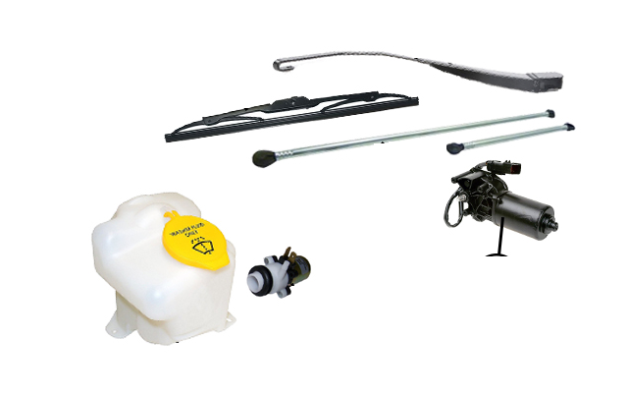

A windshield wiper is a straightforward part. Yet, it relies on several different components that work together:

* Windshield wiper motor
* Windshield wiper arm
* Windshield wiper blade
* Windshield washer pump

Let's talk about each component in more detail.

### Wiper Motor

In most cars, you'll find the windshield wiper motor on the firewall in the engine compartment. It's a small tube-like motor that connects to the wiper arm. Most vehicles have two windshield wipers, so they use a linkage to connect the wiper arms. When you turn on the wipers, you kick the following events into motion:

1. The switch sends a signal to the wiper motor via the fuse and sometimes a relay.
2. The motor starts running at the speed set by the switch.
3. The windshield wiper arm is connected to the motor. When the motor is activated, the wiper arm starts moving back and forth. In doing so, it pulls the blade across the windshield.

### Wiper Arm

The wiper arm serves as the connection between the motor and the blade. It's a long stick-like part that:

* Pivots on one end (the end that connects to the wiper motor)
* Connects to the wiper blade on the other end

The wiper arm is a long plastic arm with connections at both ends. Sometimes the arm is made of plastic and metal, and some arms have joints that enable the arm to flex. Each Mazda model comes with wiper arms that are designed to work with the car's windshield. Wiper arms go through extensive testing to make sure they do a good job in all air speed and weather conditions. If you need to replace your windshield wiper arm, it's important to get one that's made for your exact Mazda model. A generic arm may lift at higher speeds, creating streaks. Or worse, not cleaning the window at all. Luckily, it's easy to find the right OEM part number. All you need to do is look up your Mazda in our [catalog of wiper arms](https://www.realmazdaparts.com/windshield-wiper-arms).

### Wiper Blade

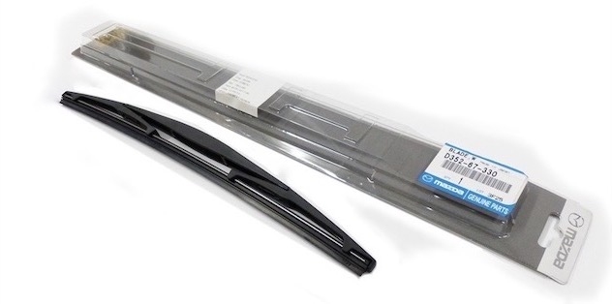

The blade is the part that wipes your windshield. It's a plastic and rubber part that connects to the wiper arm. The rubber part stays in contact with the windshield at all times. The plastic part serves as the backing, and it connects to the wiper arm.

When you activate the windshield wipers, the wiper arms drag the blades back and forth across the windshield. The rubber part wipes the moisture and debris off the windshield. This helps maintain the driver's visibility.

Wiper blades are the disposable part of the assembly. The rubber part wears out over time. Depending on how often you use your wiper blades, you should replace them every 6-12 months.

If you're looking for replacement wiper blades, look no further. We're authorized sellers of genuine OEM Mazda parts, including wiper blades. Look up your Mazda in our [catalog of wiper blades](https://www.realmazdaparts.com/windshield-wiper-blades)!

### Windshield Washer Pump

The windshield washer pump is not attached to the wiper arms, but it works with the wipers. When you spray windshield washer fluid all over the windshield, the vehicle activates the wipers. This way, the vehicle cleans the windshield on the road.

The windshield cleaning system is simple. It contains two major components:

* Windshield washer fluid reservoir
* Windshield washer pump